Watch Episode 3 of the Portfolio Playbook
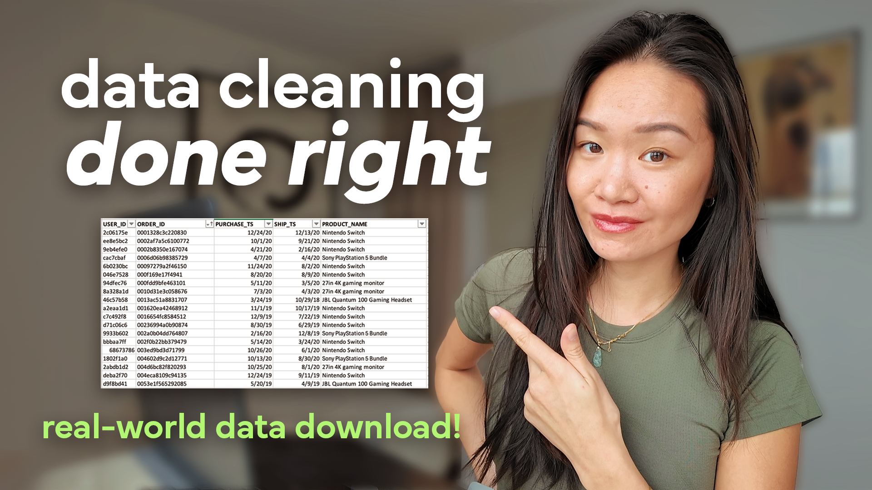
The ONLY Data Cleaning Framework You Need (Data Director Explains)

Get to know the sample company and follow along with the CLEAN Framework as you clean real-world data step by step!

